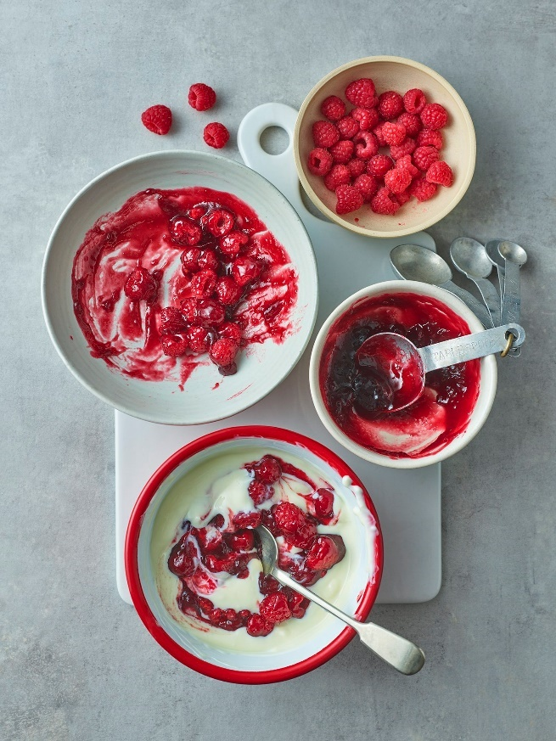Header image: ‘Welcome to Carnation’

<first name>, welcome to our Carnation baking community!

We thought we would send you our most loved recipes for baking inspiration to get you started. We’ve got you covered for every occasion! You can rate & review them online & share your bakes with our community on social media!

We can’t wait to see your creations 😊

Happy Baking,

From Carnation



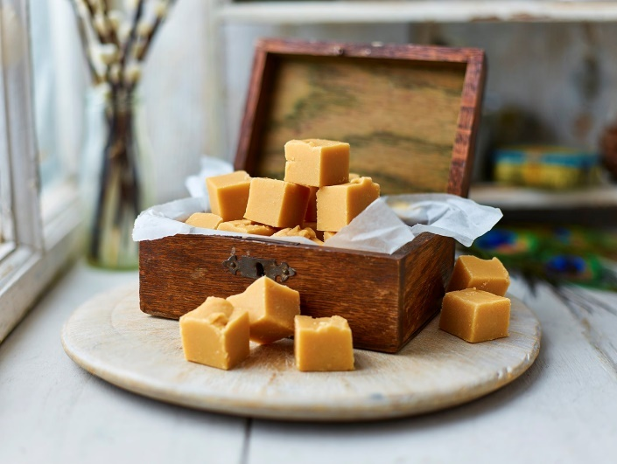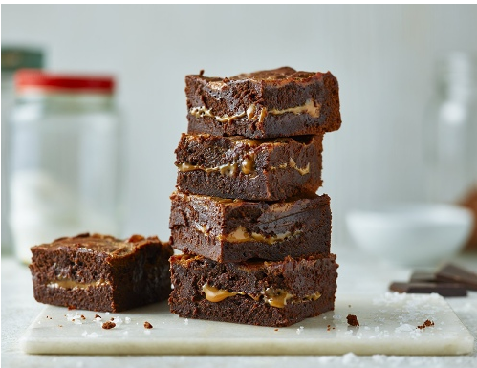

Fudge & Sweets

Caramel

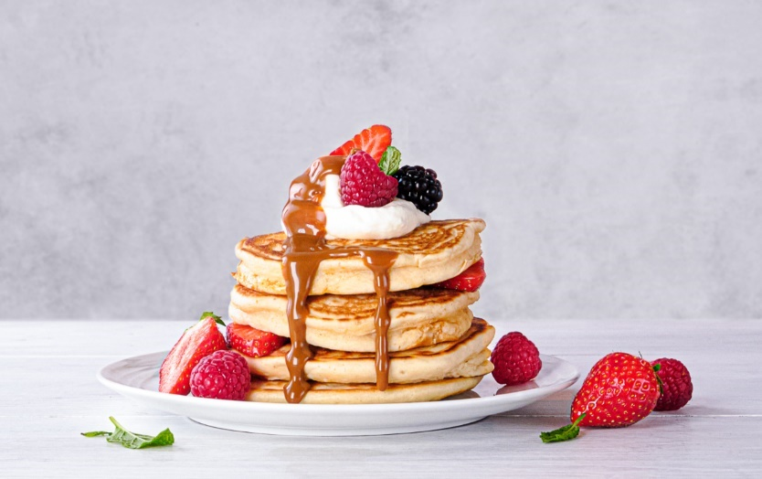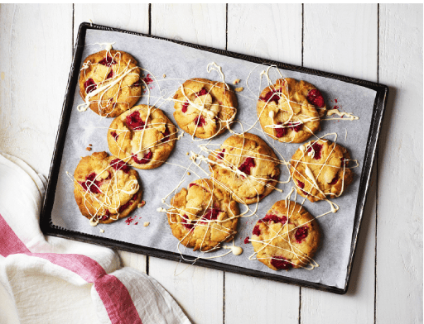

30 mins or less

Family

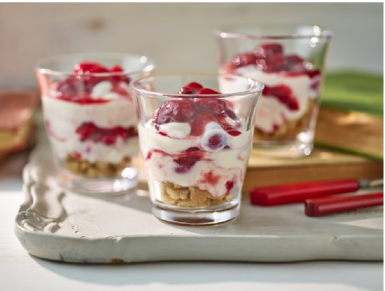

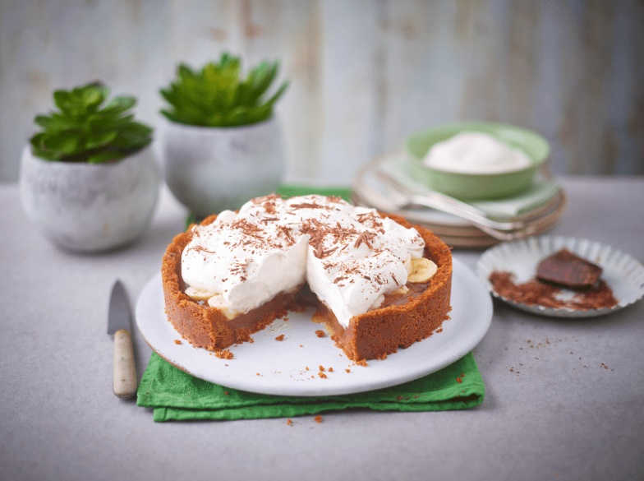

Lighter

Vegan



